**26 Oct 2018** **The Weekly Bulletin of Rotary Club of Kathmandu Mid-Town** **bc-7.10/018**

|  |
| --- |
| C:\Users\Public\Documents\RIP T1819_EN.png |

District: 3292 Web:www.rotarymidtown.org.np Club Id: 26776

**OCTOBER IS ECONOMIC AND COMMUNITY DEVELOPMENT** **MONTH**

**Economic and community development is one of Rotary’s six areas of focus.**

Determining your community’s needs and resources is an important starting point for any community project. Community assessments identify the community’s strengths and weaknesses and how Rotarians will be able to work with the community to meet its needs.

Skills and leadership development is an important component of youth employment and poverty reduction. Youth leadership development can contribute to lifting individuals out of poverty by improving access to work, increasing productivity, and fostering sustainable economic growth.

Ensure that skills development opportunities are accessible to the underserved communities and translated into livelihood improvements.

**Club Meeting # 1461** : 12 Oct 018

In-house speaker PP CA Komal B Chitracar took initiative in explaining different components of the Club’s financial statement and audit report for the year 2017-18 for helping Treasurer as well as members to get a clear view of Club’s financial status and how the project specific funds are dealt with.

# Weekly Meeting/Program Schedule:

|  |  |  |
| --- | --- | --- |
| Date | Program/ Speaker | Topic of Presentation |
| 26 October | Sarik Bogati | Service beyond Sky |

Friday Meeting: 26 Oct

Sarik Bogati is the Sales Manager of Qatar Airways in Nepal. Before joining Qatar Air he was with Etihad Airways, Volkswagen and NATTA. He got his MBA from Pokhara University. Besides his day-to-day job with Qatar Air he is also a Visiting Faculty at Ace Institute of Management and active in Toastmasters, now as VP.

**Changa Chait 2018:**

‘Changa Chait’, that is, flying kites is an integral part of celebrating Dasain. The RCKMT had a 'Changa Chait’ cum ‘Pot Luck Lunch’ program at PP CK Golchha's residence at Sitapaila on Saturday, 13 October.

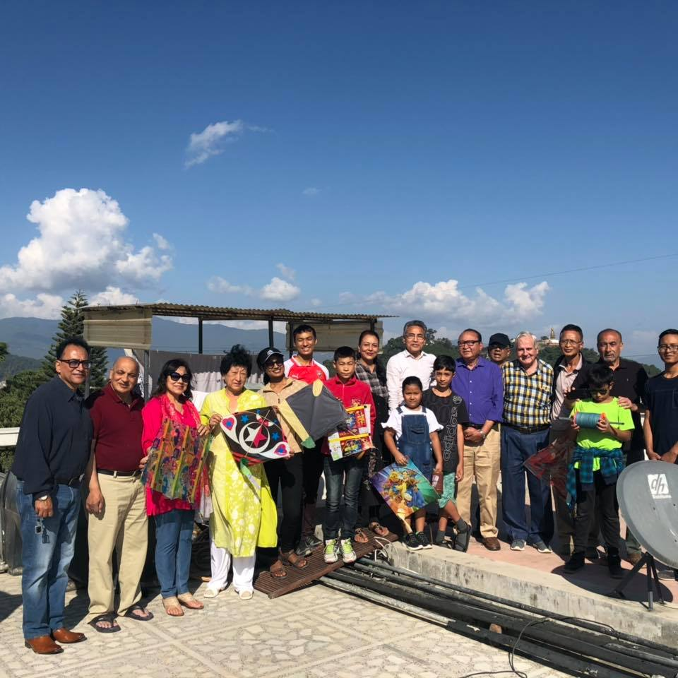

*Photo from Facebook, Neeva Pradhan*

**Dashain Tika:**

Visiting Dwarika Hotel during Dashain in one of the convenient day to wish PP Ambica Shrestha, a senior most Rotarian, a very Happy Vijaya Dashami and also to get special *Tika* from her as our *bhauju* has been a sort of custom since a couple of years. This year too, Club Secretary PP Arun coordinated and many Mid-Towners assembled at the Hotel on 20 Oct (Saturday) and wished her a very happy Vijaya Dashami and also got special *Tika* and blessings from her. A group photo while the Tika program was going on.

**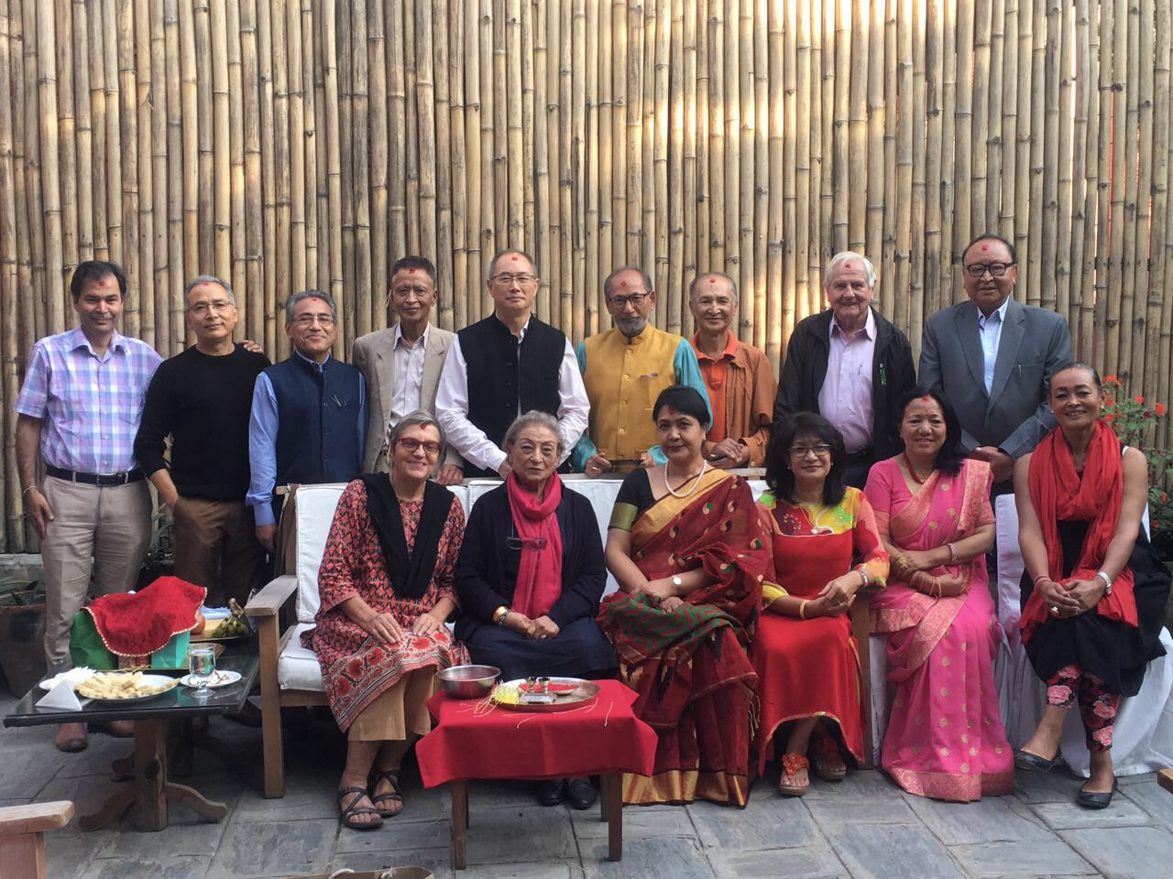**

*Photo courtsey:* *Rtn Shyam R Thapalia*

**[Vocational Training for Youth:](http://www.brainyquote.com/quotes/quotes/b/baruchspin101666.html" \o "view quote)**

A vocational training for youth was planned for college students and Rotaracts in 3 parts; the first and second part are already completed in last week of Sept and first week of Oct 2018.

The third part of this Training is scheduled to be held on Tuesday 6 Nov at Xavier Academy, Lazimpat.

The program is organized by Kathmandu Mid-Town in coordination and support of two other partnering institutions – Nepal Ambulance Service and Xavier Academy. Besides Rotaracts of Kathmandu Mid-Town, and College students there are volunteers from Art of Living participating in the program. Rotary Club of Kathmandu Mid-Town will be providing a certificate of training on the final mock drill date to all youth participants.

**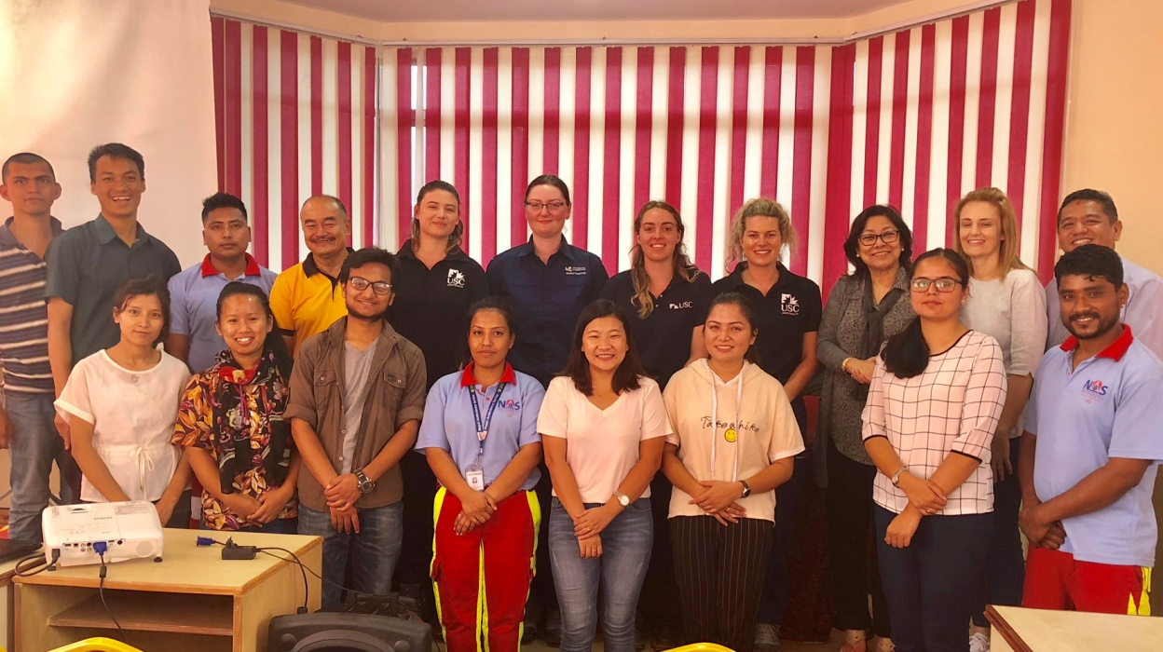**

*Photo courtsey:* *PE Neeva Pradhan*

**ROTARIAN PHOTO CONTEST 2019:**



Do you have a great shot from a club project or fundraiser?

Did you capture a memorable moment at the convention or during an

international trip?

Enter your images in The Rotarian's 2019 photo contest and you might see

them in the pages of the magazine. You may enter up to three photos taken

since 1 January 2018.

The contest closes 15 December 2018, so submit your great photos now.

Winners will appear in the June 2019 issue of The Rotarian.

*Source: Isabella Khadka,* [*isa.khadka@gmail.com*](mailto:isa.khadka@gmail.com)

**World Polio Day:**

World Polio Day is on 24 October and a great opportunity for Rotary to raise awareness in the



community about the need to eradicate polio globally. We are very close to eradicating polio now.

As of Sept 2018, there are only 18 cases of wild poliovirus in the world: Afghanistan 14 cases and

Pakistan 4 cases.

Nepal is polio free, but until the number of cases reaches zero world-wide, polio remains a threat

to all of us.

On the occasion of World Polio Day, Nepal National PolioPlus Committee organized a big rally in

Kathmandu on Wednesday 24 Oct 2018  (7 Kartik 2075).

**Polio Eradication Champion Award**

Justin Trudeau, prime minister of Canada, was presented with Rotary’s Polio Eradication Champion Award in recognition of Canada’s contributions to polio eradication.

Canada has been a strong contributor to polio eradication efforts for decades. In 2017, it pledged US$75 million to help eradicate polio, bringing its total contributions to roughly $640 million.

Rotary established the *Polio Eradication Champion Award* in 1995 to recognize heads of state, health agency leaders, and others who have made a significant contribution to polio eradication.

Trudeau is the third Canadian prime minister to receive the award, along with Jean Chrétien and Stephen Harper. Past recipients also include Shinzo Abe, prime minister of Japan; Angela Merkel, chancellor of Germany; Xavier Bettel, prime minister of Luxembourg; Muhammadu Buhari, president of Nigeria; Neven Mimica, European commissioner for international cooperation and development; and Ban Ki-moon, former UN secretary-general.

*www.endpolio.org/canada-s-prime-minister-accepts-polio-honor*.

**Committee Chairs’ Column:** *(This column is for use by chairpersons of 5 permanent committees: Club Administration, Membership, Public Relations, Service Projects, and the Rotary Foundation)*

**Members’ Corner:** *(This column is for Club members to express anything they would like in matter of Club activities, Club administration, Club issues or on Breakfast Chatter, or on anything else that would be of interest to fellow members.)*

.

**A THOUGHT FOR THE DAY:**

“If your actions inspire others to dream more, learn more, do more and become more, you are a leader.”

- *John Quincy Adams*

**Do you know?**

Rotary Club of Bangalore, D3190, created history of sorts this Feb (2018) by chartering a Rotary club which is exclusively for the differently-abled.

RC Bangalore Abilities plans to take up four major projects:

1. A campaign to sensitise the government and owners of small malls to make their facilities more disabled-friendly; 2. A job fair for the differently-abled;

3. A rural school for children with disabilities and

4. Sponsoring braille screen readers, each costing about Rs 25,000.

*Source: Rotary News April 2018*

On Lighter Side:

A new vacuum cleaner salesman knocked on the door on the first house of the street.

A tall lady answered the door.

Before she could speak, the enthusiastic salesman barged into the living room and opened a big black plastic bag and poured all the cow droppings onto the carpet.

"Madam, if I could not clean this up with the use of this new powerful vacuum cleaner, I will *eat* all this ...!" exclaimed the eager salesman.

"What do you need, chilli sauce or ketchup with that" asked the lady.

The bewildered salesman asked, "Why, madam?"

"We just moved in, and there's no electricity in the house!"

It can be tempting, when our priority is service, to focus only on the things that look like service: the

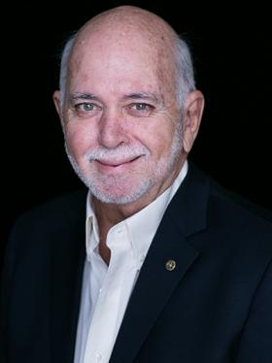

projects, the planning, the work that yields a visible benefit to those who need it. But to do that work

effectively, we need to keep our own house in order. In Rotary, that means conducting ourselves in

accordance with the principles of Rotary, treating others with respect, and following The Four-Way

Test. It means maximizing our impact by planning carefully and stewarding our resources wisely.

**RI President Barry Rassin**

Please send information on club activities, progress reviews on service projects, relevant photos etc to:

BC Editor: RR Shrestha email: rryesrr@gmail.com

## 26 Oct 2018 The Weekly Bulletin of Rotary Club of Kathmandu Mid-Town bc-7.10/018